Brute force geometric
1.closest pair brute force
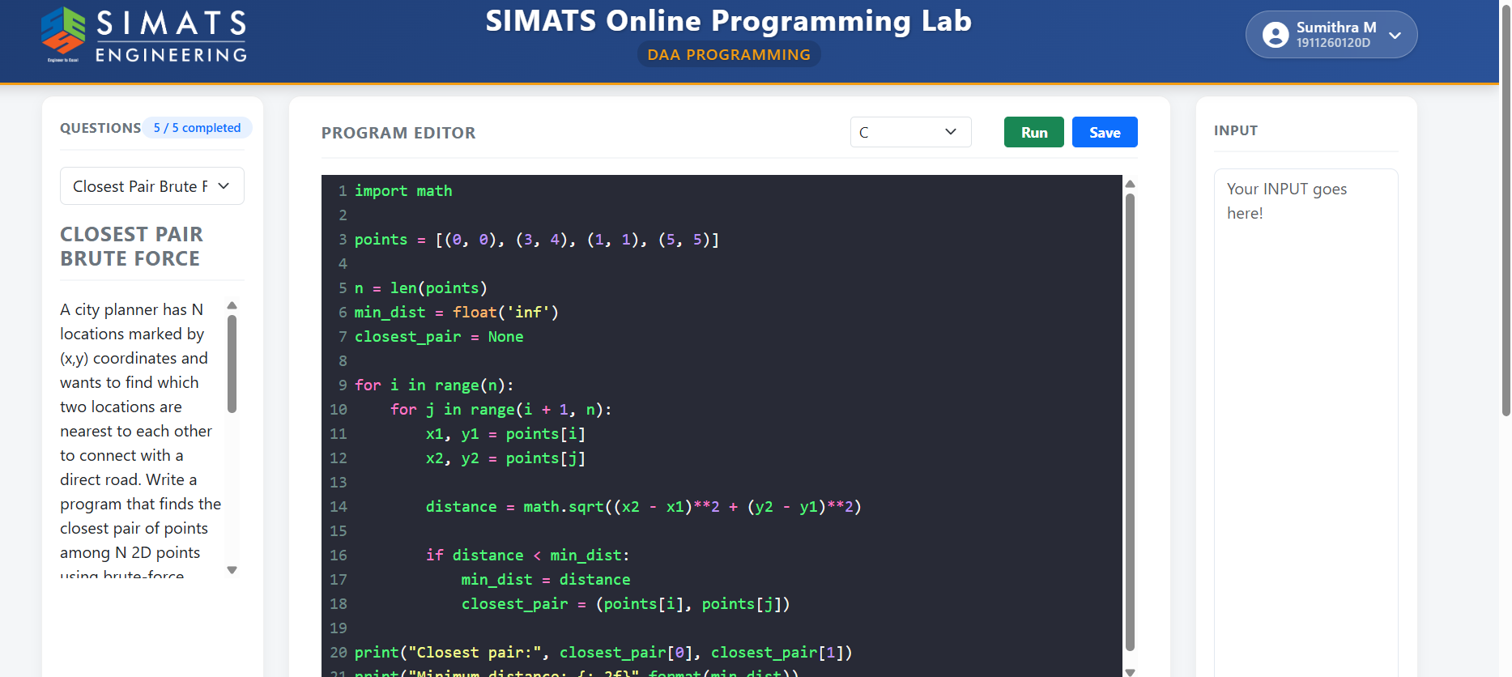
2.exhaustive subset sum
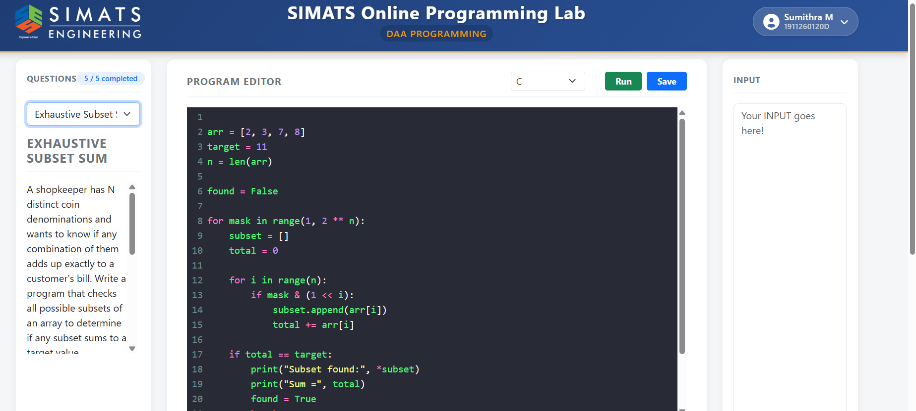
3.

